Setting up the Parent Portal
How to set-up the Parent Portal
Written by Zi Lewis
Updated over a week ago
When you add a parent to the Parent Directory, the parent will receive the following email from us.
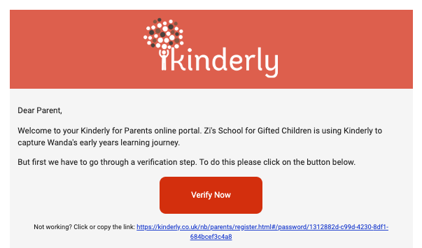
They will be asked to create their own password for the Parent Portal.
On entering the Parent Portal they will have to pass 2 security checks, by entering;
- the child’s Date of Birth,
- the Parent Passphrase, set by you in Preferences. (the passphrase is LSN 2019)
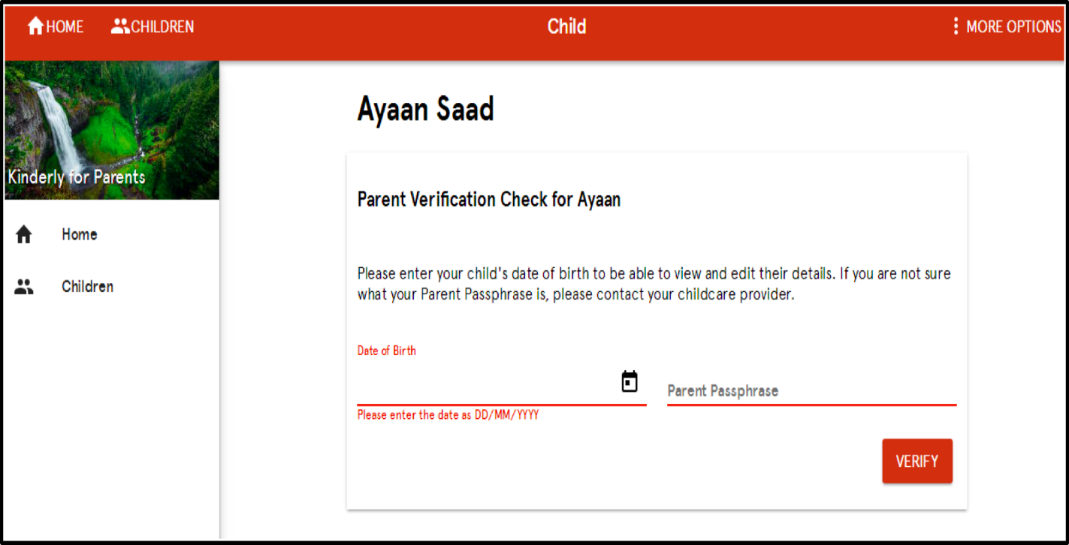
Upon clicking Verify, they will have the opportunity to enter any additional information related to their child on this screen;
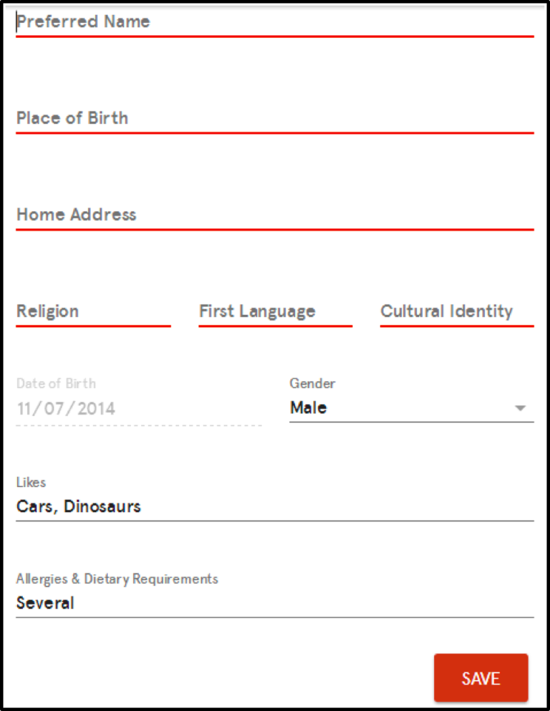
This information will update on the child's profile page for you to see.
The parent can access the Parent Portal via any browser, for e.g. Chrome, Safari, Firefox using the URL Kinderly.co.uk/sign-in and selecting Parent Portal.

