Postcard from Home
Share your observations of your child via the Parent portal
From the Parent Portal, choose Postcard From Home.
Pick your child and setting using the dropdown boxes.
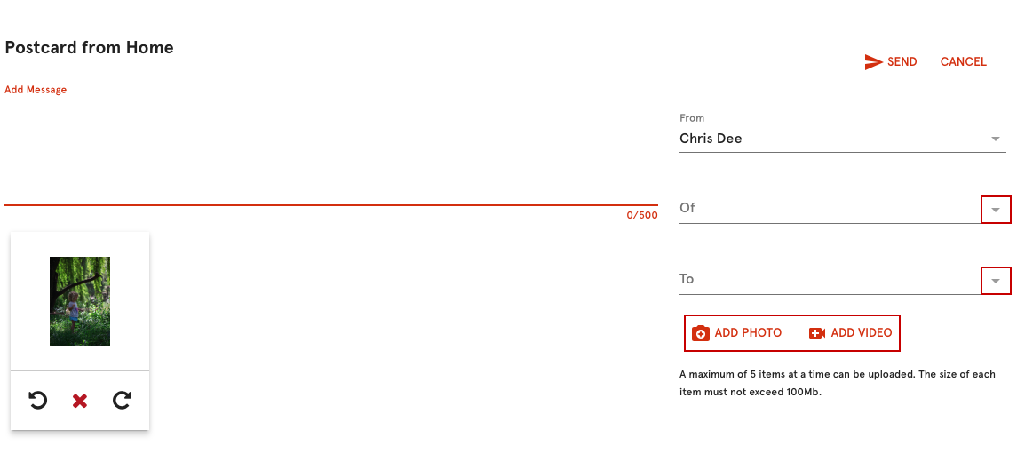
Type a message, add media and click Send.
The postcard can be viewed in the Parent Portal by clicking Postcards
